Curriculum Vitae
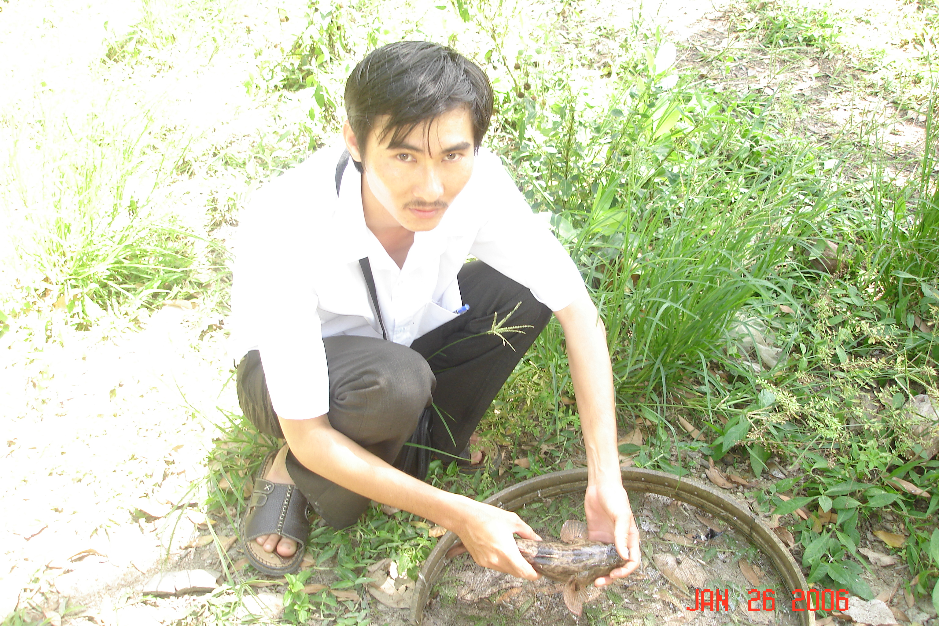
1. FAMILY NAME: Võ Trung
2. FIRST NAME: Oai
3. DATE OF BIRTH: 19/06/1980
4. PLACE OF BIRTH: Lương Tâm, Long Mỹ, Hậu Giang
5. NATIONALITY: Vietnam
6. EDUCATION: Aquaculture University
7. LANGUAGES SKILLS:

8. COMPUTER SKILLS: Word, Excel, Access, Outlook Express, Power Point.

9. PRESENT POSITION:

Acting Director, The Anh Dương Community Development and Support Center.

10. YEARS WITH THE NGO:

Since 2007

11. KEY QUALIFICATIONS:
- Staff Management
- Establish and Manage the Project
- Community Development Project Monitoring
- Management skills for middle management
- Change management skills

12. PROFESSIONAL EXPERIENCE:

2007-2008 :
Aquaculture staff of the project
2008-9/2012:
Project Vice Director who is in charge of poor household program, Agriculture program, computer program.
9/2012- present
Acting Director of Anh Duong Center
13. OTHER PROFESSIONAL EXPERIENCES:

2010 - 2011: Coordinate mainly the project “Improve rural people’s awareness about climate change” sponsored by World Bank.
2012: Coordinate the project “Financial Management” sponsored by HSBC Bank

14. REFERENCES :
- Bernard Kervyn (Mekong Plus Director): bernard.kervy@gmail.com . Tel: 08 8940797 & 0913 105189
- Tài Đại Thành, (Anh Duong Director) Tel: 072 822437 & 0913 876138
- Nguyễn Văn Ngẫu ( Director of Technology and Science Department in Hau Giang province): Tell 0913871150
- Bùi Văn Thắng (Vice Chairman of Long My People Committee) Tell 0918221916

15. ADDRESS :
Võ Trung Oai
Ánh Dương Community Development and Support Center
Fax & tel.: 84-7113-607680
Email: anhduong.longmy@gmail.com
Website of Ánh Dương: www.anhduonghg.org

