600$ for the bridge in Luong Nghia
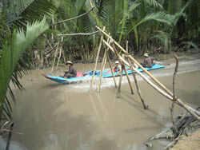
In the densely populated Mekong delta of Vietnam, bridges and roads are a crucial factor to unlock the development of entire villages. In Luong Nghia the “monkey bridge” is used by hundreds of households, thousands cross the bridge everyday. There are accidents so that the parents of young children prefer to delay their education by 2 years. Poor people do not have a boat, when they need to go to the hospital for an emergency, they must ask their neighbors for help.
The development of agriculture is seriously hampered. The crops and pigs cannot be carried to the market, so the prices are fixed by the middlemen who come by boat. The farmers estimate their loss at 20% of the normal price.
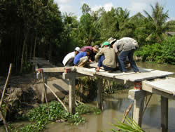
The villagers have asked Mekong Plus, the local partner of Operation USA, for help. The 2 meter wide bridge will cost 1700$. The villagers will provide part of the materials and volunteer their labor, so that Mekong Plus is only asked to contribute for 600$.
The “monkey bridge” in Luong Nghia. Below: one of the 70 bridges already built.
Another clear benefit of the bridge is that it will be used by an estimated 300 motorcycles a day, which will save them about 3 kilometers. The petrol saved alone is estimated at over 4000$ per year!
Mekong Plus is an experienced organization doing community development in Vietnam and Cambodia. It has already built over 70 bridges and 75 km of small village roads.

By Ms.HUYNH HOANG To Trinh in the delta, and Bernard KERVYN
April 25, 2009
Nickname: A 600$ bridge
Tags: Vietnam, Mekong delta, Mekong Plus, development.
Budget: 600$
Category: poverty
Charity: Operation USA

