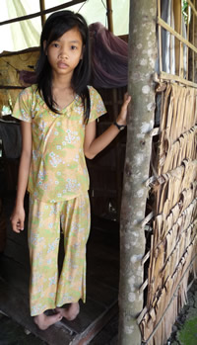
Nhi, Top of the Class
Nhi is 12 years old and lives with her mother and a brother. Her father died. The family has no land, the eldest brother works in a factory in Saigon. Fortunately, because he sends a bit of money – about 10 euros – every month.

Nhi is in sixth grade and has a major handicap: she has two club feet. Amazingly, she still manages to walk to school, 3km away. It takes her more than two hours each way. She is very motivated and intelligent, and she is almost always top of the class. But now she is finding it hard as problems at home are multiplying. Her brother’s kidney problems are worsening. During the last monsoon season the small house collapsed, and the neighbours rushed to help. Together they fixed it – a fine act of solidarity.

The household’s income? Nhi’s mother works on a day rate, and when she has work, that is about one day out of three, she gets roughly 1.75 euro. That adds up to less than 100 euros per person per year.

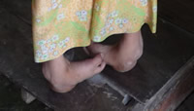
Clearly, it’s necessary to tackle problems one by one. Trinh, member of Mekong Plus, says: “I’m confident as the community is already mobilised to help out. For the house, we are gathering contributions, the local council has promised to participate, and we will provide the rest. A small hard house of about 30m2 costs about 400 euros. Our agronomist is assessing what we could do, perhaps a small vegetable garden with a microcredit – but where? They don’t have a patch of land. Of course we need to take care of Nhi. We will take her to the hospital for an in-depth examination. I hope we will be able to straighten her feet. We will probably need 200 euros and the community should then provide 2/3, us the rest.

I remember Nhi’s words when I left them: “My dream? That my mother and my brother are well!” And I looked at her feet... determined to find a solution.

Trinh and Bernard KERVYN, 2/4/2009.

